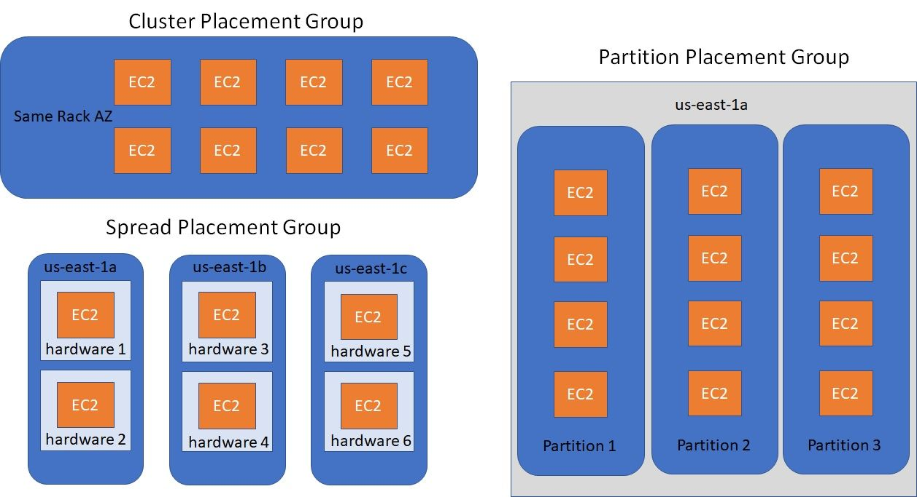

### Cluster

* Same rack and same availability zone
* Great network, low latency (10Gbps bandwidth between instances)
* Cons: if rack fails then all the EC2 instances will fail at the same time
* Usage: Big data job that needs to complete fast, Application with low latency and high throughput

### Spread

* All EC2 instance will be located on different hardware
* Span across multiple AZ
* Reduced risk of simultaneous failure
* Limit of 7 instances per AZ per placement group
* Usage: Application that needs maximize HA , Critical Applications that needs to be isolated from failure from each other

### Partition

* Upto 7 partitions per AZ with 100s of EC2 instances
* The instances of 1 partition do not share racks with instances of other partitions
* A partition failure can affect many EC2 instances from same partition but it won't affect other EC2 instances on other partitions
* EC2 instances can get access to the partition information using metadata
* Usage: HDFS, HBase, Cassandra, Kafka